Introduction to Database Lab-2:

NAME: MD. ABDULLAH AL NOMAN ID: 22-47844-2

1. select \*from emp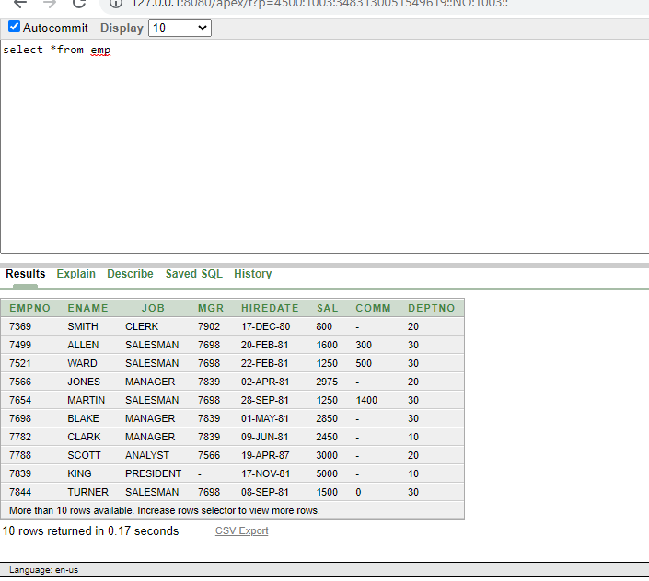
2. select \*from dept

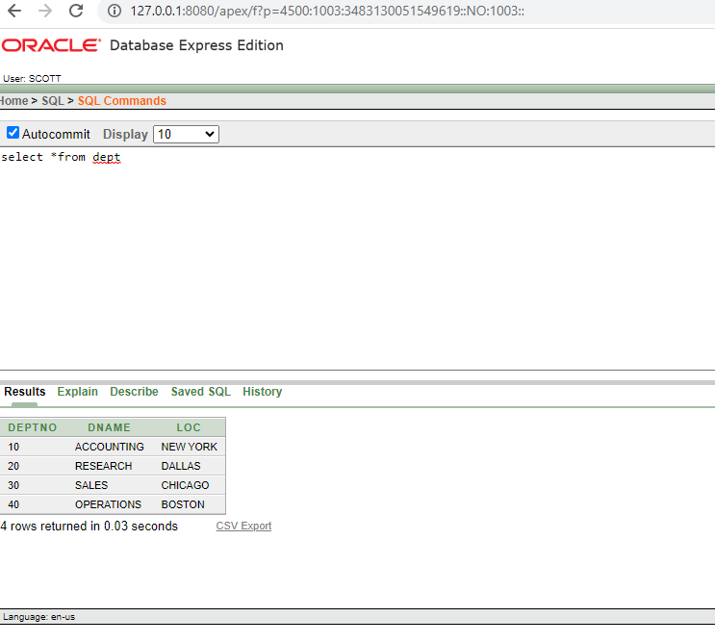

1. select deptno, loc from dept

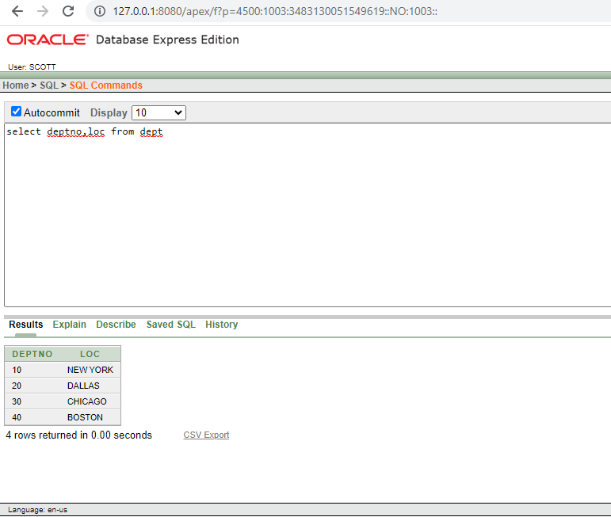

1. select ename, sal, sal+300 from emp

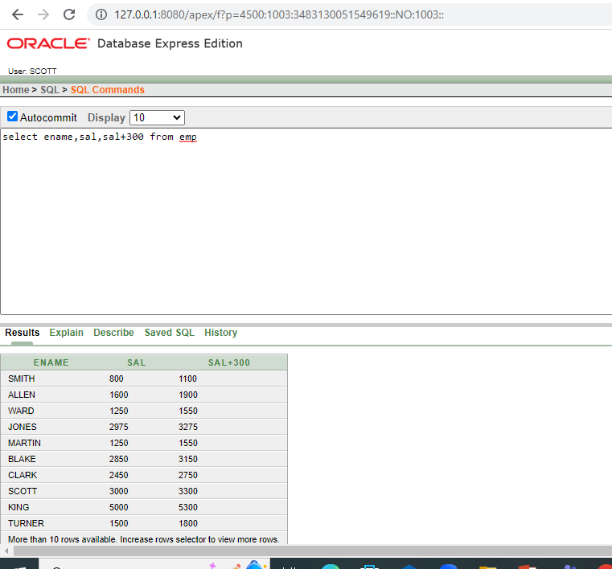

1. select ename, sal, 12\*sal+100 from emp

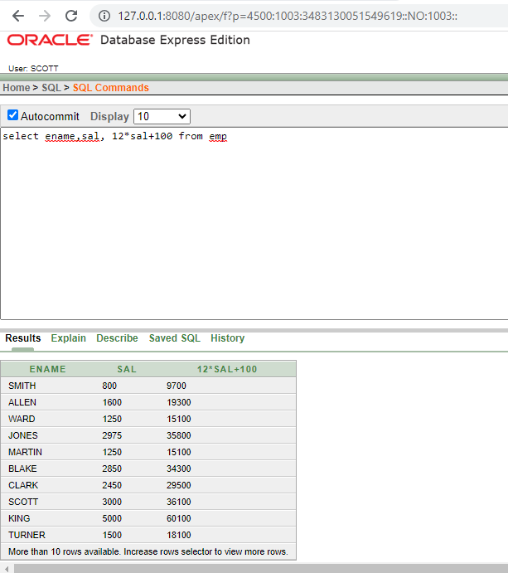

1. select ename, sal, 12\*(sal+100) from emp

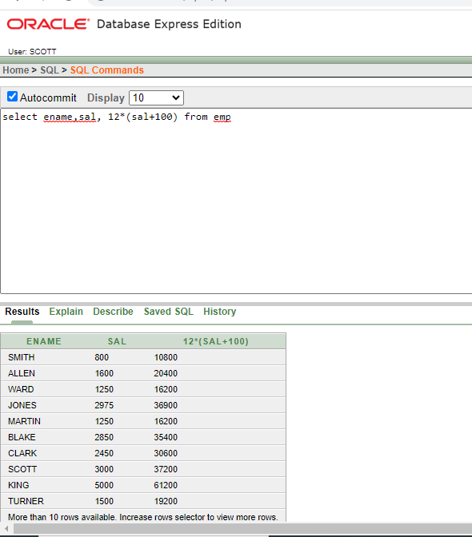

1. select ename, job, comm from emp

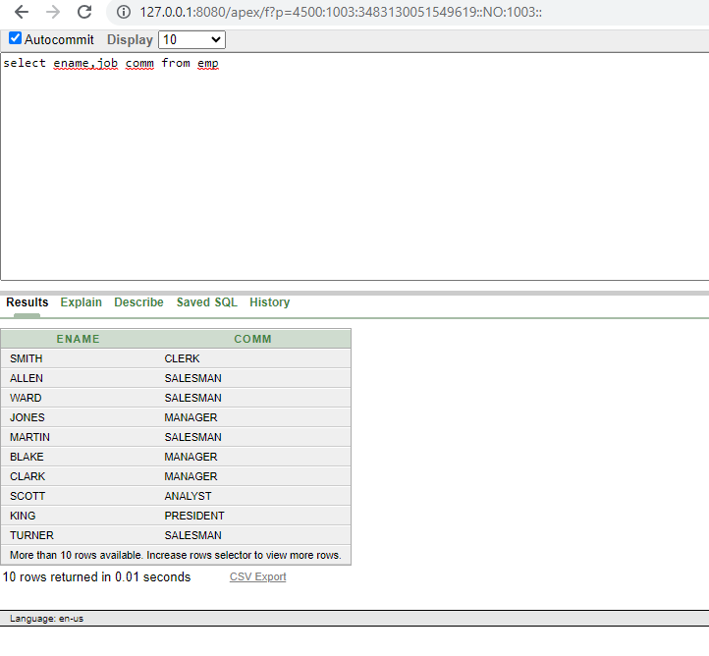

1. select ename, 12\*sal+comm from emp where ename= ‘KING’

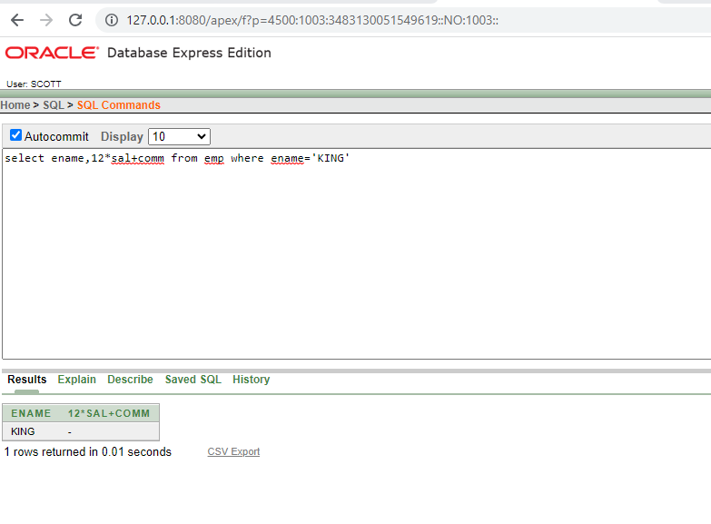

1. select ename As name, sal salary from emp

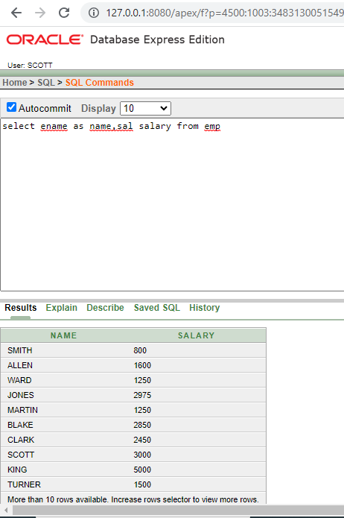

1. select ename “Name”, sal 12\* “Annual Salary” from emp

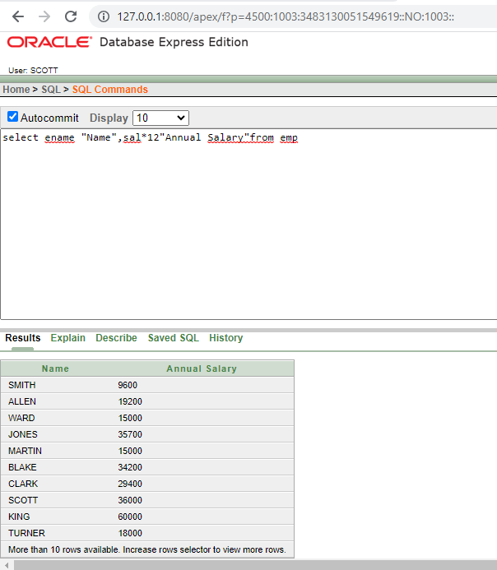

1. select ename || job As “Employee” from emp

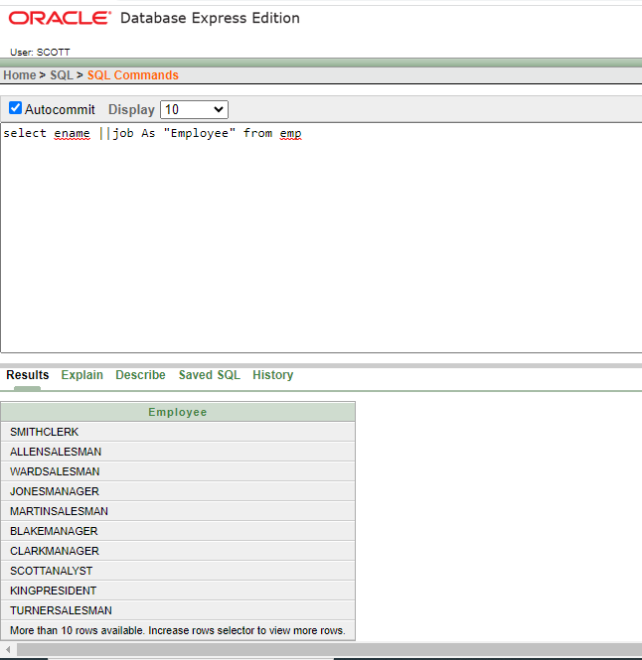

1. select ename ||' '||'is a'||' '||job as "Employee Details" from emp

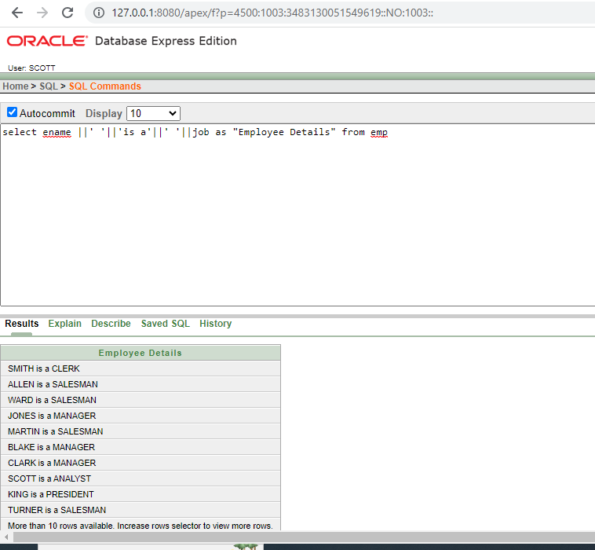

1. select deptno from emp

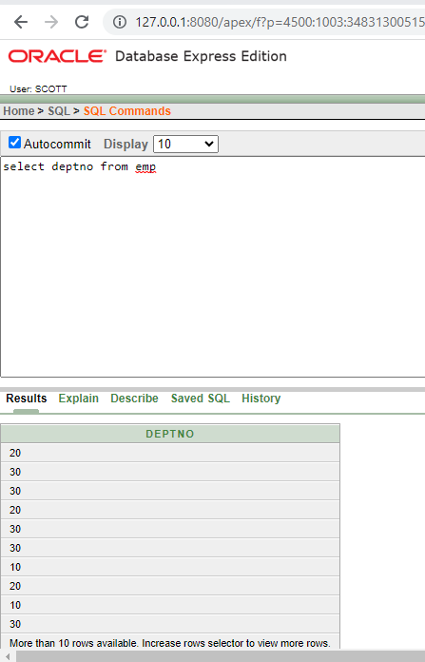

1. select DISTINCT deptno from emp

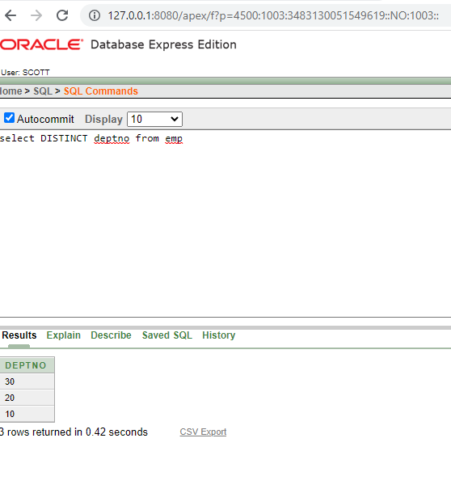

1. DESCRIBE dept

